Please tell us about your child. This helps us to prepare for their induction and also helps their key-worker to get to know them.
My special people are…

My favourite nursery rhyme, song or story is…

Does anything frighten you or is there anything you really don’t like?

Can you speak/understand another language?

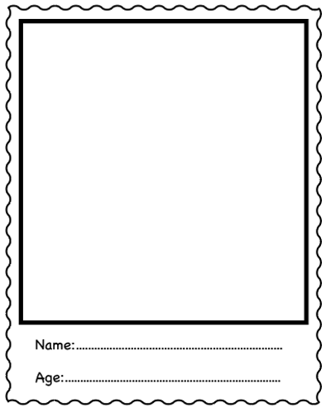
Do you live in a house/flat/bungalow/caravan?

Do you go to any clubs?

My favourite colour is…

Do you have any special friends?

My favourite film/TV program and/or character is…

Do you have any pets or a favourite animal?

My favourite toy/comfort object is…

Do you go on days out or holidays? If so, where?

My favourite snack is…

My favourite thing to do at home is…

